REGULAR EXPRESSIONS TO CHANGE LC CALL NUMBER TO NLM CALL NUMBER USING MARCEDIT

Put space in classification: ([A-Z])([0-9])

$1 $2

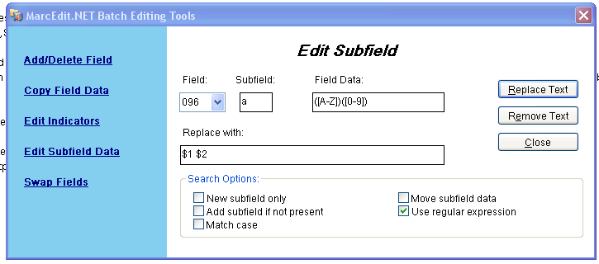

Take out space in any subclassifications \.([A-Z]) ([0-9])

.$1$2

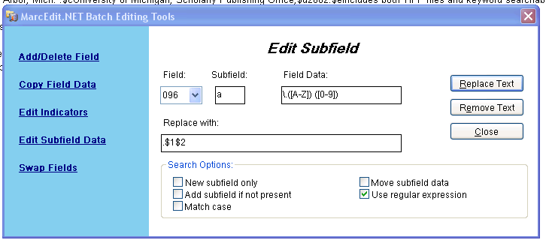

Take out decimal point in subfield b

